Day 22 – Time-Based Feature Engineering

Lag Features :

Lags are simply the previous time stamps used as predictors for the current time step. For Example, while forecasting today’s temperature, rain predictions, or sales for a multi-store, we might use yesterday’s and days before as features.

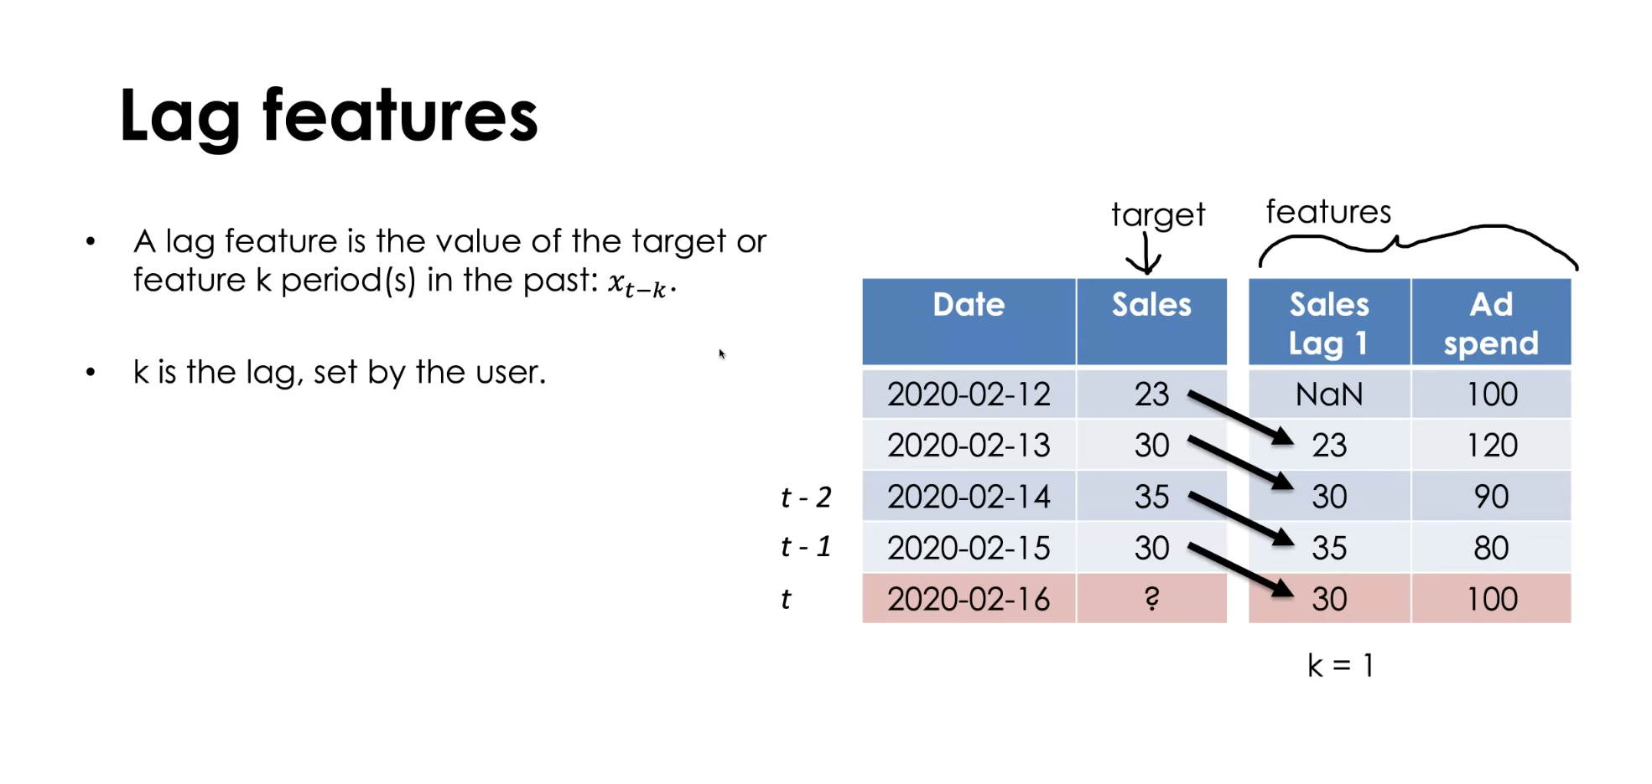

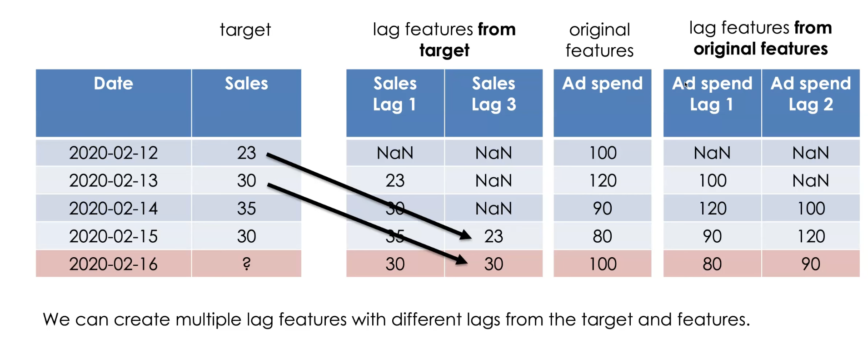

Rolling Averages:

The rolling means in time series analysis are a technique of examining the historical data by breaking it sequentially and in into fixed segments, which move forward with time.
This helps in processing of metrics such as, moving averages (MA), or other statistical formats over a specific period. This helps further to identify the trends, seasonality patterns and all over changes in data in time.
Rolling Window Statistics are based on past behavior within a fixed window to capture trends and local variability.
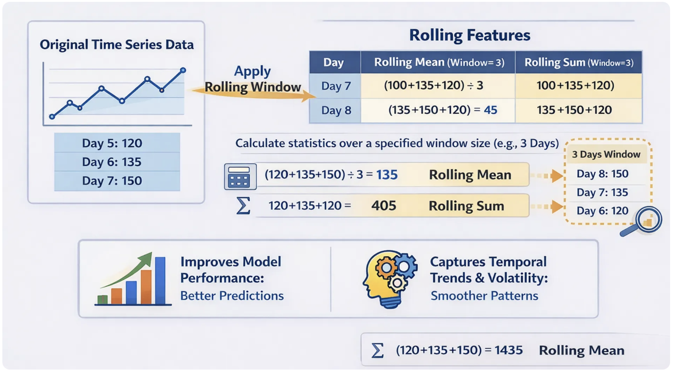
df['rolling_mean_3'] = df['temperature'].rolling(window=3).mean()
df['rolling_mean_7'] = df['temperature'].rolling(window=7).mean()
Date features:

Date time features are features created from the time stamp value of each observation. A few examples of these features are the integer hour, month, and day of week for each observation.

df['day'] = df.index.day
df['month'] = df.index.month
df['year'] = df.index.year
df['day_of_week'] = df.index.dayofweek
df['week_of_year'] = df.index.isocalendar().week

By leveraging this additional knowledge, such as hour, month, and day of week values, data scientists can gain additional insights on their data and on the relationship between the input features and the output feature and eventually build a better model for their time series forecasting solutions.

